Keompok Ular Piton
TI-42-11

Anggota:
- Raka Aditya Prayoga (1201184359)
- Dimas G. Priandoni (1201180443)
- Putu Panji L (1201180273)
- Emeliawaty (1201184221)
- Mahendra Maulana .T (1201174127)
- Aulia Naufal Ramadhan (1201174323)
- R. Moh. Rizal Ramdani (1201174228)

Uler Piton Group
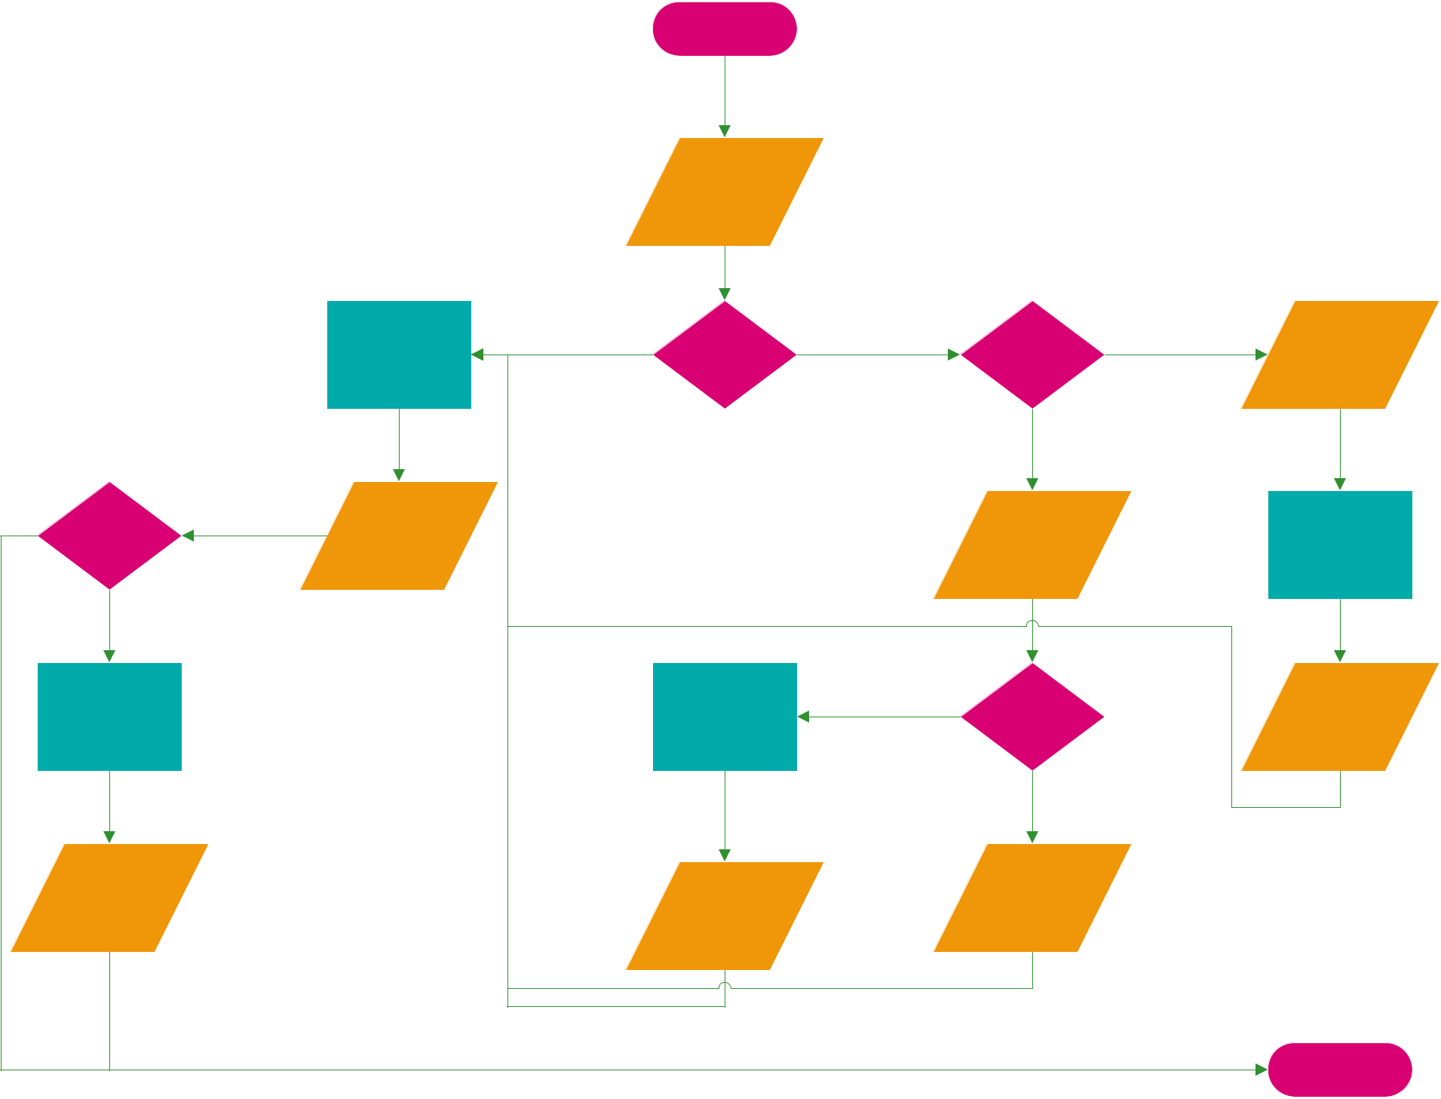

START

Input PIN

 |  | Cek Saldo |  | Transaksi |  | Debit
 |  | Cek Saldo |  | Transaksi |  | Input
 |  | Kalkulasi Saldo | Transaksi / |  |  | Input
 |  | Kalkulasi Saldo | Transaksi / |  | Debit / Credit | Nominal
 |  | Akhir | Cek Saldo |  | Debit / Credit | Nominal
 |  | Akhir | Cek Saldo |  |  | Top Up
 |  |  |  |  | Credit
 | Cetak Struk | Jumlah |  |  | Input
 | Cetak Struk | Saldo |  |  | Nominal | Transfer Saldo
 |  |  |  |  | Penarikan
No | Yes
 |  |  | Pengurangan | Yes | Saldo | Saldo
 | Proses Pencetakan |  | Pengurangan |  | Saldo | Saldo
 | Proses Pencetakan |  | Saldo |  | Mencukupi | Tertambah
 |  |  |  |  | No
 | Struk |  | Saldo |  | Transaksi
 | Tercetak |  | Saldo |  | Gagal
 |  |  | Berkurang
 |  |  |  |  |  | END

